**WIREFRAME**

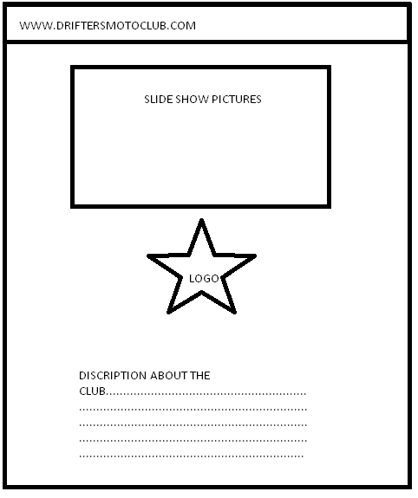

**HOME PAGE**

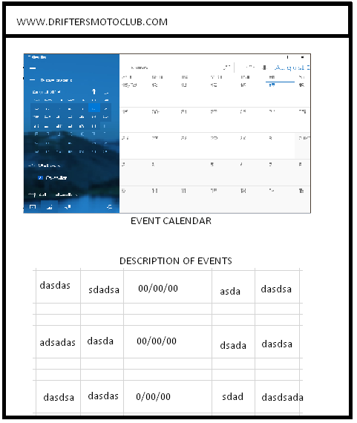

**EVENT PAGE**

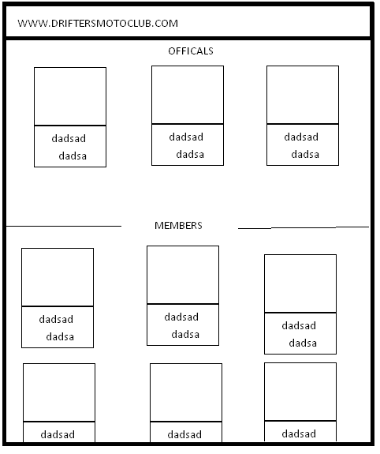

**MEMBERS PAGE**

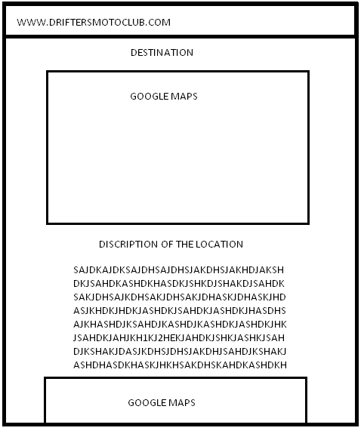

**DESTINATION PAGE**

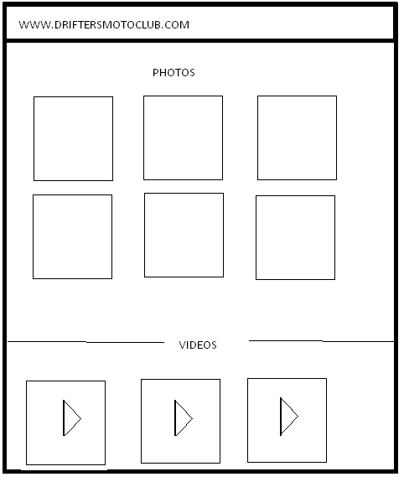

**GALLERY PAGE**

**ADMIN PAGES**

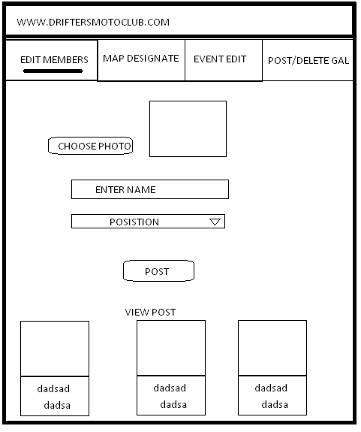

**ADMIN MEMBER**

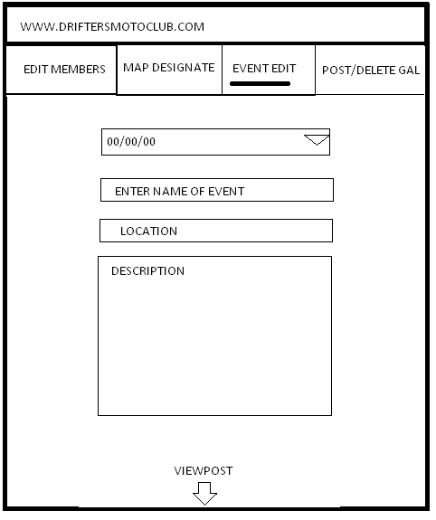

**EVENT ADMIN**

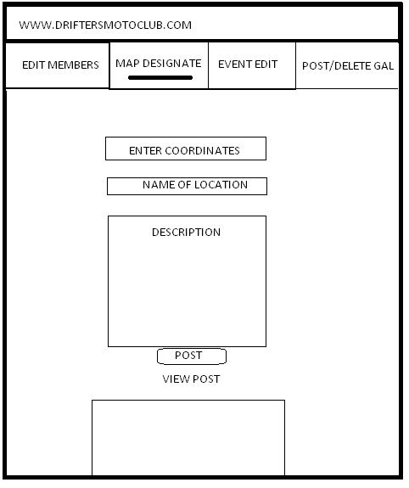

**MAP ADMIN**

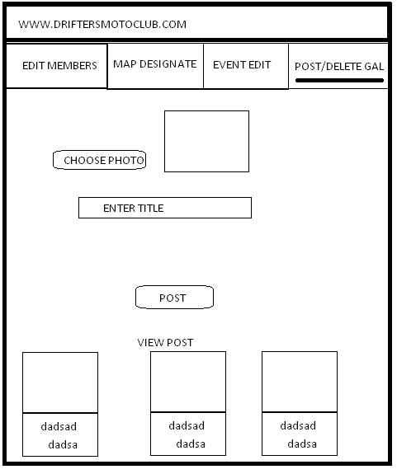

**GALLERY ADMIN**